MASTER STUDY GUIDE
Chapter 4: The Market Forces of Supply and Demand
Principles of Economics, 8th Edition | N. Gregory Mankiw
Integrated Study Notes with Bangladesh Examples, Exam Tips, and Practice Questions

PART 1: Markets and Competition
Supply and demand are the two most powerful forces in economics. They determine how much of each good is produced and at what price it is sold. To understand any economic event or policy, you must first understand how it affects supply and demand.

1.1 What Is a Market?
DEFINITION — Market
A group of buyers and sellers of a particular good or service. Buyers determine the demand side. Sellers determine the supply side. Together, they form the market.

Markets can be organized or informal. They can exist in one place or be spread across many locations.

Type of Market | Description | Bangladesh Example
Organized Market | Buyers and sellers meet at a specific place and time. Rules and prices are clear. | Dhaka Stock Exchange (DSE); commodity auctions
Informal Market | No single meeting place. Buyers choose freely from different sellers. | Karwan Bazar (vegetables and fish); local bazaars
Digital Market | Buyers and sellers interact online through a platform. | Chaldal.com (groceries); Bikroy.com (buy and sell)

Bangladesh Example — The Rice Market
Thousands of farmers grow rice across Bangladesh (supply side). Millions of families buy rice every day (demand side). Together, they form the rice market. The price of rice is not set by any one person. It is determined by the interaction of all buyers and sellers.

1.2 What Is a Competitive Market?
DEFINITION — Competitive Market
A market with so many buyers and sellers that each individual buyer or seller has a negligible impact on the market price. No single participant can control the price.

DEFINITION — Price Taker
A buyer or seller who must accept the market price as given. They are too small to influence the price.

DEFINITION — Perfect Competition
The highest level of competition, with two key conditions: (1) All goods sold are exactly identical. (2) No single buyer or seller has any influence over the market price. All participants are price takers.

Example: One rice farmer in Bangladesh sells 500 kg of rice. The total market produces millions of kilograms. That one farmer cannot raise or lower the rice price. The farmer is a price taker.

1.3 Other Market Structures
Not all markets are perfectly competitive. Mankiw introduces other structures briefly. Chapter 4 focuses on perfect competition because it is the simplest to analyze, and many lessons apply to more complex markets as well.

Market Structure | Number of Sellers | Price Control | Bangladesh Example
Perfect Competition | Many | None — all are price takers | Rice market, vegetable market
Monopoly | One | Full control over price | DESA (electricity supply in Dhaka)
Oligopoly | Few | Significant control | Mobile operators: Grameenphone, Robi, Banglalink
Monopolistic Competition | Many | Some control (unique products) | Local restaurants in Dhaka

PART 2: Demand

2.1 What Is Quantity Demanded?
DEFINITION — Demand
The relationship between the price of a good and the quantity that buyers are willing and able to purchase.

DEFINITION — Quantity Demanded
The specific amount of a good that buyers are willing AND able to purchase at a given price. Both conditions must be true: willing (desire) and able (can afford).

Important: A person who wants a BMW car (willing) but cannot afford it (not able) does not add to quantity demanded. Both conditions must be satisfied.

2.2 The Law of Demand
LAW OF DEMAND
Other things being equal, when the price of a good rises, the quantity demanded falls. When the price falls, the quantity demanded rises. Price and quantity demanded move in opposite directions (inverse relationship).

Bangladesh Example — Ilish Fish
When the price of Ilish fish is 200 Tk per kg, many families buy it regularly. When the price rises to 800 Tk per kg, fewer families buy it. During Eid, when the price rises further, only wealthy families can afford it. This is the Law of Demand in action.

2.3 The Demand Schedule
DEFINITION — Demand Schedule
A table that shows the relationship between the price of a good and the quantity demanded, holding all other factors constant.

Example — Catherine's demand for ice cream cones per month:

Price per Cone | Quantity Demanded (cones/month)
$0.00 (Free) | 12
$0.50 | 10
$1.00 | 8
$1.50 | 6
$2.00 | 4
$2.50 | 2
$3.00 | 0

As price increases from $0.00 to $3.00, the quantity demanded falls from 12 to 0. This confirms the Law of Demand.

2.4 The Demand Curve
DEFINITION — Demand Curve
A graph that shows the relationship between the price of a good and the quantity demanded. Price (P) is on the vertical axis (Y-axis). Quantity (Q) is on the horizontal axis (X-axis). The curve slopes downward.

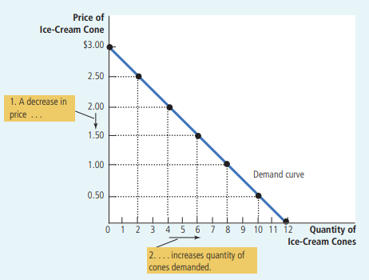

2.5 The Demand Equation
FORMULA — Linear Demand Equation
Qd​=a−bP

Where: Qd = Quantity demanded |
P = Price |
a = Quantity demanded when price is zero |
b = Responsiveness of demand to price (slope coefficient).
The negative sign confirms the inverse relationship.

Worked example: Qd = 20 − 3P
Price (P) | Calculation | Quantity Demanded (Qd)
P = 1 | 20 − 3(1) = 17 | 17 units
P = 2 | 20 − 3(2) = 14 | 14 units
P = 3 | 20 − 3(3) = 11 | 11 units

2.6 Slope of the Demand Curve
FORMULA — Slope of Demand Curve
Slope = ΔP ÷ ΔQd = (Change in Price) ÷ (Change in Quantity Demanded) Using points (P=2, Qd=14) and (P=3, Qd=11): Slope = (2 − 3) ÷ (14 − 11) = −1 ÷ 3 = −1/3 The slope is negative. This confirms the demand curve slopes downward. For every 1-unit rise in price, quantity demanded falls by 3 units.

2.7 Individual Demand vs. Market Demand
Individual demand shows how much one person buys at each price. Market demand is the total demand of all buyers combined. To find market demand, add the quantities demanded by all buyers at each price level.

Example — Market demand for ice cream (Catherine + Nicholas):
Price | Catherine | Nicholas | Market Total
$0.00 | 12 | 7 | 19
$1.00 | 8 | 5 | 13
$2.00 | 4 | 3 | 7
$3.00 | 0 | 1 | 1

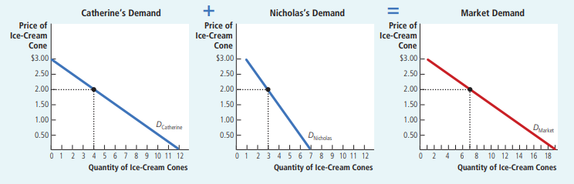

2.8 Shifts in the Demand Curve
The demand curve shifts when something other than price changes. The entire curve moves to a new position.
- Shift to the RIGHT = Increase in demand (buyers want MORE at every price).
- Shift to the LEFT = Decrease in demand (buyers want LESS at every price).

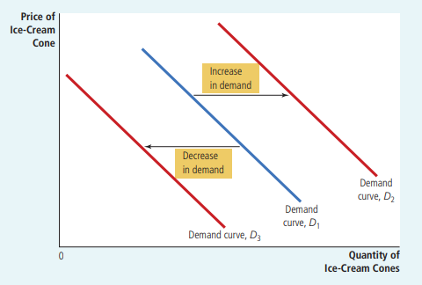

Factors That Shift the Demand Curve (Determinants of Demand)

Factor | Direction of Shift | Bangladesh Example
Income rises — Normal Good | Demand INCREASES → Curve shifts RIGHT | Higher salary → buy more chicken and fish
Income rises — Inferior Good | Demand DECREASES → Curve shifts LEFT | Higher salary → buy fewer bus tickets, switch to Uber
Price of Substitute rises | Demand INCREASES → Curve shifts RIGHT | Hilsa fish price rises → demand for Rohu fish rises
Price of Complement rises | Demand DECREASES → Curve shifts LEFT | Bread price rises → demand for butter falls
Tastes improve | Demand INCREASES → Curve shifts RIGHT | Doctor recommends vegetables → more vegetable demand
Positive Expectations | Demand INCREASES → Curve shifts RIGHT | Ramadan approaching → people buy rice early
Number of Buyers increases | Demand INCREASES → Curve shifts RIGHT | Population growth → more rice demand in Bangladesh

2.9 Movement Along Curve vs. Shift of Curve
CRITICAL RULE — Movement vs. Shift (Demand)
Movement ALONG the demand curve: Caused ONLY by a change in the PRICE of the good itself. The demand curve stays in the same place. Shift OF the demand curve: Caused by a change in income, related goods prices, tastes, expectations, or number of buyers. The entire curve moves to a new position.

Concept | Cause | Called | Example
Movement ALONG curve | Price of the good changes | Change in Quantity Demanded | Tea price falls → more tea demanded (move down the curve)
SHIFT of curve | Income, tastes, related goods, etc. change | Change in Demand | Cold winter → more tea demanded at every price (curve moves right)

DEFINITION — Normal Good vs. Inferior Good
Normal Good: Demand RISES when income rises. Examples: Rice, fish, chicken. Standard behavior. Inferior Good: Demand FALLS when income rises. Examples: Bus rides, cheap soap. When income rises, people switch to better alternatives. Note: 'Inferior' does not mean the product is bad. It only describes how demand responds to income.
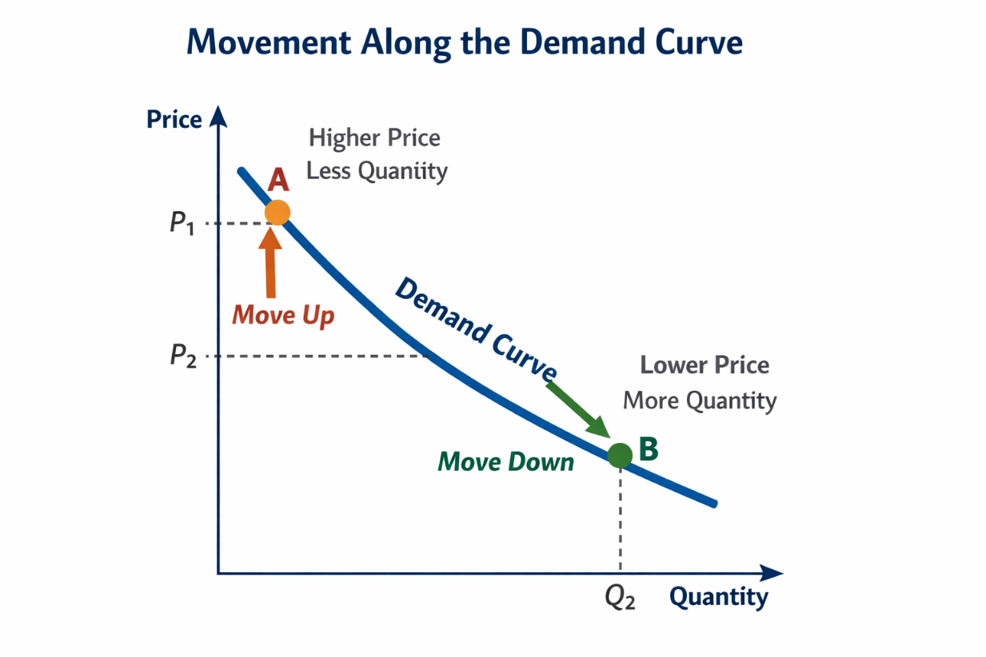

DEFINITION — Substitutes vs. Complements
Substitutes: Two goods that can replace each other. If the price of Good A rises, demand for Good B rises. Example: Hilsa fish and Rohu fish; rice and bread. Complements: Two goods used together. If the price of Good A rises, demand for Good B falls. Example: Tea and sugar; car and petrol.

PART 3: Supply

3.1 What Is Quantity Supplied?
DEFINITION — Supply
The relationship between the price of a good and the quantity that sellers are willing and able to sell.

DEFINITION — Quantity Supplied
The specific amount of a good that sellers are willing AND able to sell at a given price.

3.2 The Law of Supply
LAW OF SUPPLY
Other things being equal, when the price of a good rises, the quantity supplied rises. When the price falls, the quantity supplied falls. Price and quantity supplied move in the same direction (direct relationship).

Why does the supply curve slope upward? When a price is high, selling is more profitable. Sellers work longer hours, hire more workers, and produce more. When a price is low, production is less profitable. Sellers produce less — some may stop entirely.

Bangladesh Example — Garment Industry
When the global price of t-shirts rises, Bangladeshi garment factories increase production. They run extra shifts, hire more workers, and buy more fabric. Quantity supplied increases. This is the Law of Supply in action.

3.3 The Supply Schedule and Supply Curve
DEFINITION — Supply Schedule
A table that shows the relationship between the price of a good and the quantity supplied, holding all other factors constant.

Example — Ben's supply of ice cream cones per month:
Price per Cone | Quantity Supplied (cones/month)
$0.00 | 0
$0.50 | 0
$1.00 | 1
$1.50 | 2
$2.00 | 3
$2.50 | 4
$3.00 | 5

DEFINITION — Supply Curve
A graph that shows the relationship between price and quantity supplied. Price (P) is on the vertical axis. Quantity (Q) is on the horizontal axis. The curve slopes upward (positive slope).

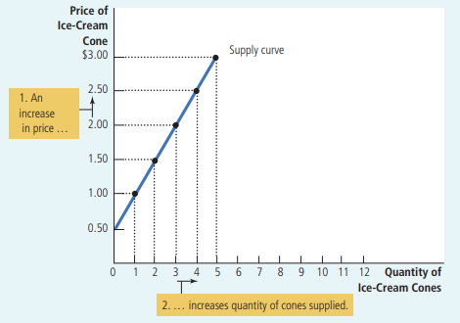

3.4 Individual Supply vs. Market Supply
Individual supply shows how much one seller supplies at each price. Market supply is the total from all sellers combined.

Price | Ben | Jerry | Market Total
$1.00 | 1 | 0 | 1
$1.50 | 2 | 2 | 4
$2.00 | 3 | 4 | 7
$2.50 | 4 | 6 | 10
$3.00 | 5 | 8 | 13

The market supply curve is found by adding all individual supply curves horizontally.

3.5 Shifts in the Supply Curve
The supply curve shifts when something other than price changes.
- Shift to the RIGHT = Increase in supply (sellers want to sell MORE at every price).
- Shift to the LEFT = Decrease in supply (sellers want to sell LESS at every price).

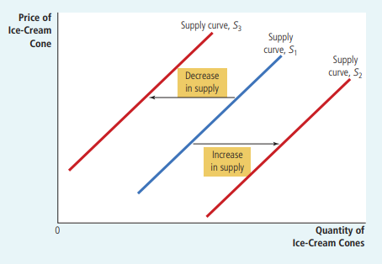

Factors That Shift the Supply Curve (Determinants of Supply)

Factor | Direction of Shift | Bangladesh Example
Input Prices rise | Supply DECREASES → Curve shifts LEFT | Gas price rises → transport costs rise → fewer vegetables reach market
Input Prices fall | Supply INCREASES → Curve shifts RIGHT | Cheaper fabric → garment factories produce more shirts
Technology improves | Supply INCREASES → Curve shifts RIGHT | New rice harvesting machine → more rice production at lower cost
Sellers expect higher future prices | Supply DECREASES today → Curve shifts LEFT | Sellers store goods now to sell at higher prices later
Number of Sellers increases | Supply INCREASES → Curve shifts RIGHT | More garment factories open → more clothing produced

3.6 Movement Along Curve vs. Shift of Curve (Supply)
CRITICAL RULE — Movement vs. Shift (Supply)
Movement ALONG the supply curve: Caused ONLY by a change in the PRICE of the good itself. Shift OF the supply curve: Caused by a change in input prices, technology, expectations, or number of sellers.

3.7 Summary Table — Supply Curve Shifts
Variable | What Happens to Supply Curve
Price of the good itself changes | Movement ALONG the curve — not a shift
Input prices rise | Supply decreases → Curve shifts LEFT
Input prices fall | Supply increases → Curve shifts RIGHT
Technology improves | Supply increases → Curve shifts RIGHT
Sellers expect higher future prices | Supply decreases today → Curve shifts LEFT
Number of sellers increases | Supply increases → Curve shifts RIGHT

PART 4: Supply and Demand Together — Equilibrium

4.1 What Is Equilibrium?
DEFINITION — Equilibrium
The point where the supply curve and the demand curve intersect. At this point, quantity supplied equals quantity demanded. The market is balanced.

DEFINITION — Equilibrium Price
The price at which quantity supplied equals quantity demanded. It is also called the market-clearing price.

DEFINITION — Equilibrium Quantity
The quantity of a good bought and sold at the equilibrium price.

Example: In the textbook ice cream market, equilibrium price = $2.00 per cone and equilibrium quantity = 7 cones. At this price, sellers want to sell exactly 7 cones, and buyers want to buy exactly 7 cones. The market is balanced.

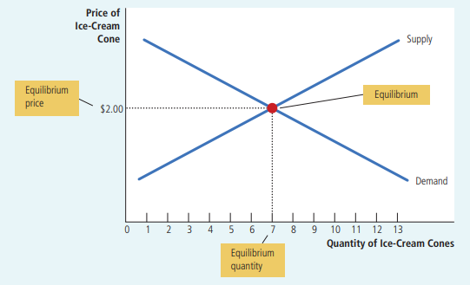

4.2 Surplus and Shortage
DEFINITION — Surplus (Excess Supply)
When the market price is ABOVE the equilibrium price. Quantity supplied exceeds quantity demanded. Sellers have more goods than buyers want. Sellers respond by lowering prices. The market returns to equilibrium. Example: Price = $2.50. Supply = 10 cones. Demand = 4 cones. Surplus = 6 cones.

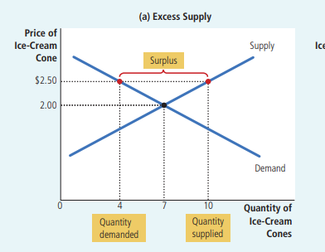

DEFINITION — Shortage (Excess Demand)
When the market price is BELOW the equilibrium price. Quantity demanded exceeds quantity supplied. Buyers compete for limited goods. Sellers raise prices. The market returns to equilibrium. Example: Price = $1.50. Demand = 10 cones. Supply = 4 cones. Shortage = 6 cones.

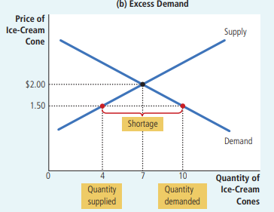

LAW OF SUPPLY AND DEMAND
The price of any good adjusts automatically to bring the quantity supplied and the quantity demanded into balance. Markets naturally move toward equilibrium over time.

Situation | What Happens | Result
Price > Equilibrium (Surplus) | Sellers have unsold goods. They cut prices. | Price falls back toward equilibrium.
Price < Equilibrium (Shortage) | Buyers compete for scarce goods. Sellers raise prices. | Price rises back toward equilibrium.
Price = Equilibrium | Market clears. No pressure on price. | Price remains stable.

Bangladesh Example — Eid Cattle Market
Before Eid, demand for cattle rises sharply. There are not enough cattle to meet demand (shortage). Prices rise. After Eid, many unsold cattle remain (surplus). Prices fall. The market naturally moves toward equilibrium in both cases.

PART 5: Analyzing Changes in Equilibrium

5.1 The Three-Step Method
THE 3-STEP METHOD — Analyzing Any Market Change
Step 1: Decide whether the event shifts the SUPPLY curve, the DEMAND curve, or BOTH. Step 2: Decide which DIRECTION the curve shifts (shift RIGHT = increase; shift LEFT = decrease). Step 3: Draw the new supply-and-demand diagram. Compare the new equilibrium to the old equilibrium. Note how price and quantity changed.

5.2 Worked Example 1: Demand Increases (Hot Weather and Ice Cream)
Event: A very hot summer occurs. How does this affect the ice cream market?
- Step 1: Hot weather affects the DEMAND curve. It changes how much people want to buy at any given price. The supply curve is not affected.
- Step 2: Hot weather makes people want more ice cream. Demand INCREASES. Demand curve shifts to the RIGHT.
- Step 3: At the old price of $2.00, there is now excess demand (shortage). Sellers raise prices. New equilibrium: price rises from $2.00 to $2.50. Quantity rises from 7 to 10 cones.

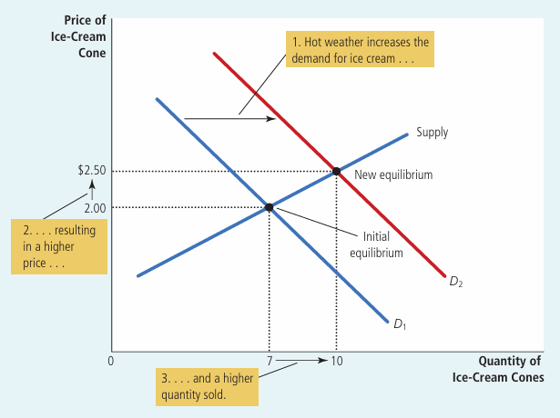

KEY RESULT
An increase in demand raises BOTH the equilibrium price AND the equilibrium quantity.

5.3 Worked Example 2: Supply Decreases (Sugar Price Rises)
Event: A hurricane destroys sugarcane crops. Sugar prices rise. How does this affect the ice cream market?
- Step 1: Higher sugar prices affect the SUPPLY curve. Sugar is an input for making ice cream. Higher input costs reduce supply. The demand curve is not affected.
- Step 2: Higher costs mean sellers supply LESS at every price. Supply DECREASES. Supply curve shifts to the LEFT.
- Step 3: At the old price of $2.00, there is now excess demand. Sellers raise prices. New equilibrium: price rises from $2.00 to $2.50. Quantity falls from 7 to 4 cones.

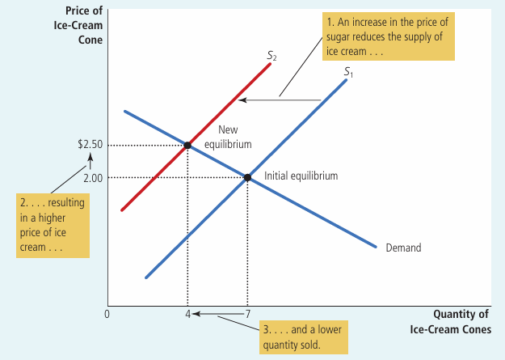

KEY RESULT
A decrease in supply raises the equilibrium price and lowers the equilibrium quantity.

5.4 Worked Example 3: Both Curves Shift Simultaneously
Event: A hot summer (increases demand) AND a hurricane that raises sugar prices (decreases supply) occur at the same time.
- Step 1: BOTH curves shift.
- Step 2: Demand curve shifts RIGHT (hot weather). Supply curve shifts LEFT (higher sugar costs).
- Step 3: Both shifts push price UPWARD. The direction of quantity change depends on which shift is larger.

Scenario | Effect on Price | Effect on Quantity
Demand rises more than supply falls | Price rises | Quantity rises
Supply falls more than demand rises | Price rises | Quantity falls
Both shifts are equal | Price rises | Quantity unchanged

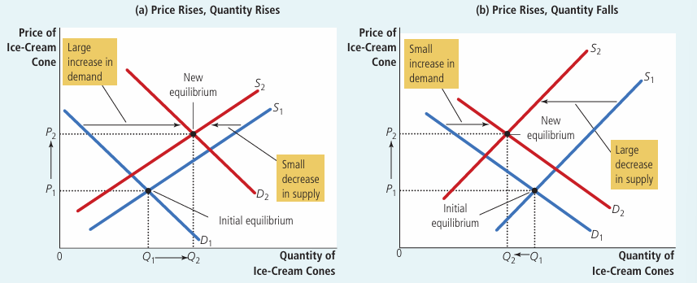

KEY RESULT
When both curves shift, the direction of the price change is usually certain. The direction of the quantity change is ambiguous — it depends on the relative size of each shift.

5.5 Complete Summary Table — All Possible Curve Shifts
Event | Curve Shift | Price Effect | Quantity Effect
Demand increases | D shifts RIGHT | Rises | Rises
Demand decreases | D shifts LEFT | Falls | Falls
Supply increases | S shifts RIGHT | Falls | Rises
Supply decreases | S shifts LEFT | Rises | Falls
D increases + S increases | Both RIGHT | Ambiguous | Rises
D decreases + S decreases | Both LEFT | Ambiguous | Falls
D increases + S decreases | D right, S left | Rises | Ambiguous
D decreases + S increases | D left, S right | Falls | Ambiguous

5.6 Master Outcomes Table (Rows = Demand; Columns = Supply)
 | Supply Unchanged | Supply Increases | Supply Decreases
Demand Unchanged | P same, Q same | P falls, Q rises | P rises, Q falls
Demand Increases | P rises, Q rises | P ambiguous, Q rises | P rises, Q ambiguous
Demand Decreases | P falls, Q falls | P falls, Q ambiguous | P ambiguous, Q falls

PART 6: How Prices Allocate Resources
In a market economy, prices serve a very important signaling role. They guide decisions without any central authority giving orders.

Price Signal | Message to Buyers | Message to Sellers
High price | This good is scarce or valuable. Buy less. | This good is profitable. Produce more.
Low price | This good is plentiful. Buy more freely. | This good is less profitable. Produce less.

CONCEPT — Adam Smith's Invisible Hand
Adam Smith described prices as an 'invisible hand' that guides the economy. Nobody plans the economy centrally. Yet millions of individual decisions — all guided by prices — lead to an efficient allocation of resources across society. The price system is the tool the invisible hand uses.

Bangladesh Example — The IT Labor Market
When IT companies in Dhaka need more programmers, they offer higher salaries (a higher price for labor). This signal attracts more people to study computer science. The market, through price alone, guides human resources to where they are needed — without any central planner deciding.

PART 7: All Key Terms — Quick Reference Glossary
Term | Simple Definition
Market | A group of buyers and sellers of a particular good or service.
Competitive Market | A market with many buyers and sellers; price is set by the market, not by any individual.
Price Taker | A buyer or seller who accepts the market price and cannot change it.
Perfect Competition | All goods are identical; no single person can influence the price.
Monopoly | Only one seller in the market; that seller sets the price.
Oligopoly | A few large sellers who have significant influence over price.
Monopolistic Competition | Many sellers, each with a slightly different product; some price control.
Quantity Demanded | The amount buyers are willing and able to purchase at a given price.
Law of Demand | Price rises → Quantity demanded falls. An inverse relationship.
Demand Schedule | A table showing quantity demanded at each price level.
Demand Curve | A graph of the demand schedule; slopes downward.
Normal Good | Demand rises when income rises. Example: fish, chicken.
Inferior Good | Demand falls when income rises. Example: bus rides, cheap soap.
Substitutes | Two goods where a price rise in one increases demand for the other.
Complements | Two goods used together; price rise in one reduces demand for the other.
Quantity Supplied | The amount sellers are willing and able to sell at a given price.
Law of Supply | Price rises → Quantity supplied rises. A direct relationship.
Supply Schedule | A table showing quantity supplied at each price level.
Supply Curve | A graph of the supply schedule; slopes upward.
Equilibrium | The point where quantity supplied equals quantity demanded. The market is balanced.
Equilibrium Price | The price at which the market clears (quantity supplied = quantity demanded).
Equilibrium Quantity | The amount bought and sold at the equilibrium price.
Surplus | Quantity supplied exceeds quantity demanded; price is too high.
Shortage | Quantity demanded exceeds quantity supplied; price is too low.
Law of Supply and Demand | Price adjusts automatically until quantity supplied equals quantity demanded.
Invisible Hand | Adam Smith's concept that prices guide resources to their most valued uses without central planning.

PART 8: Key Comparisons and Distinctions

8.1 Movement Along a Curve vs. Shift of the Curve
Concept | Cause | What Moves | Graph Effect
Movement along demand curve | Price of the same good changes | One point to another on the same curve | Travel up or down the curve
Shift of demand curve | Income, tastes, related goods, expectations, or number of buyers changes | The entire demand curve | A new curve appears (left or right)
Movement along supply curve | Price of the same good changes | One point to another on the same curve | Travel up or down the curve
Shift of supply curve | Input prices, technology, expectations, or number of sellers changes | The entire supply curve | A new curve appears (left or right)

8.2 Surplus vs. Shortage
Feature | Surplus (Excess Supply) | Shortage (Excess Demand)
When does it occur? | Market price is ABOVE equilibrium | Market price is BELOW equilibrium
Who has the problem? | Sellers cannot sell everything | Buyers cannot buy everything they want
Market response | Sellers cut prices | Sellers raise prices
Final result | Price falls toward equilibrium | Price rises toward equilibrium
Numeric example | Supply(10) > Demand(4); surplus of 6 | Demand(10) > Supply(4); shortage of 6

8.3 Normal Goods vs. Inferior Goods
Feature | Normal Good | Inferior Good
When income rises | Demand increases | Demand decreases
When income falls | Demand decreases | Demand increases
Bangladesh examples | Rice, fish, chicken, clothing | Bus rides, cheap soap, instant noodles

8.4 Substitutes vs. Complements
Feature | Substitutes | Complements
Definition | Goods that replace each other | Goods used together
If price of Good A rises | Demand for Good B rises | Demand for Good B falls
Bangladesh examples | Hilsa fish and Rohu fish; Rice and bread | Tea and sugar; Car and petrol
Textbook examples | Ice cream and frozen yogurt | Ice cream and hot fudge

PART 9: Practice Questions with Answers

Section A — Markets and Competition
Q1. What is a competitive market? Describe a market that is not perfectly competitive.
MODEL ANSWER
A competitive market has many buyers and sellers, with no single participant able to affect the market price. All participants are price takers. A non-competitive example: DESA (electricity in Dhaka) is a monopoly — one seller sets the price. Grameenphone, Robi, and Banglalink form an oligopoly in the mobile market — a few large sellers with significant pricing power.

Section B — Demand
Q2. Does a change in PRICE shift the demand curve or cause a movement along it?
MODEL ANSWER
A change in the PRICE of the good itself causes a MOVEMENT ALONG the demand curve. Quantity demanded changes, but demand does not shift. A change in income, tastes, related goods prices, expectations, or number of buyers causes a SHIFT of the entire demand curve.

Q3. Harry's income falls, and he buys more pumpkin juice. Is pumpkin juice a normal good or an inferior good?
MODEL ANSWER
Pumpkin juice is an INFERIOR good. When Harry's income falls, his demand for pumpkin juice increases. The demand curve for pumpkin juice shifts to the RIGHT (increases). This is the defining characteristic of an inferior good.

Section C — Supply and Equilibrium
Q4. Does a change in technology shift the supply curve or cause a movement along it?
MODEL ANSWER
A change in technology causes a SHIFT of the supply curve. Better technology lowers production costs, so sellers supply more at every price. The supply curve shifts to the RIGHT (supply increases). A change in the PRICE of the good causes a movement along the existing supply curve.

Q5. The price of tomatoes rises. What happens in the pizza market?
MODEL ANSWER
Tomatoes are an input for making pizza. Step 1: The supply of pizza is affected (supply curve shifts). Step 2: Higher tomato prices raise production costs. Supply decreases — supply curve shifts LEFT. Step 3: At the old price, there is now excess demand. Price rises. New equilibrium: pizza price rises and pizza quantity falls.

Q6. Beer and pizza are complements. If the price of beer rises, what happens to the pizza market?
MODEL ANSWER
Beer price rises → people buy less beer → since beer and pizza are complements (consumed together), demand for pizza falls → pizza demand curve shifts LEFT → pizza equilibrium price falls → pizza equilibrium quantity falls.

Q1: What is demand? What are the determinants of demand?
Demand is the quantity of a good that buyers are WILLING and ABLE to purchase at various prices.

Determinants of Demand (factors that SHIFT the demand curve):
1. Consumer income (normal vs. inferior goods)
2. Price of related goods (substitutes and complements)
3. Tastes and preferences of buyers
4. Expectations of future price changes
5. Number of buyers in the market

Q2: What is the Law of Demand? Prove the demand curve slopes downward.
Law of Demand: When price rises, quantity demanded falls (inverse relationship).

Proof using equation Qd = 20 - 3P:
P=1: Qd=17 P=2: Qd=14 P=3: Qd=11
As P rises, Qd falls → slope = -1/3 (NEGATIVE) → downward sloping.

Reason:
Income effect: higher price means buyers can afford less.
Substitution effect: buyers switch to cheaper substitutes.

Q3: Given a demand equation, draw a curve and calculate slope.
Example: Qd = 20 - 3P

1. Make table: (P=1, Qd=17), (P=2, Qd=14), (P=3, Qd=11)
2. Plot P on vertical axis, Qd on horizontal axis.
3. Connect points → straight downward line.

Slope = ΔP / ΔQd = (2-3) / (14-11) = -1/3

Q4: Difference between movement along curve vs. shift in demand curve.
 | Movement Along Curve | Shift of Curve
Cause | Price of the good changes | Income, tastes, related goods, expectations
Curve stays? | YES — same curve | NO — whole curve moves left or right
Name | Change in Quantity Demanded | Change in Demand

Q5: If consumer income rises and raw material price falls — what happens to equilibrium?
Consumer income rises → Demand INCREASES → D shifts RIGHT
Raw material price falls → Production cost falls → Supply INCREASES → S shifts RIGHT

Result:
Equilibrium Quantity: DEFINITELY RISES (both shifts push Q up)
Equilibrium Price: AMBIGUOUS (D increase pushes P up; S increase pushes P down)
Final price depends on which shift is larger.

Q6: Define Price Elasticity of Demand. Give the formula.
Price Elasticity of Demand (Ep) measures how sensitive Qd is to a change in price.

Formula: Ep = (% Change in Qd) / (% Change in P)
Or: Ep = (dQ/dP) x (P/Q)

If |Ep| > 1 → Elastic (sensitive buyers)
If |Ep| < 1 → Inelastic (not sensitive buyers)
If |Ep| = 1 → Unit elastic

Q7: Given P=10, Q=200 and P=8, Q=250 — calculate price elasticity.
dP = 10 - 8 = 2
dQ = 200 - 250 = -50

Ep = (dQ/dP) x (P/Q)
= (-50/2) x (10/200)
= -25 x 0.05
= -1.25

|Ep| = 1.25 > 1 → Demand is ELASTIC

PART 10: Exam Tips and Memory Aids

10.1 Top 5 Common Exam Mistakes
MISTAKE 1 — Confusing a shift with a movement along the curve
RULE: A change in the PRICE of the good causes a movement ALONG the curve. A change in any other factor (income, tastes, related goods, etc.) causes a SHIFT of the entire curve.

MISTAKE 2 — Saying 'both supply and demand increase, so price definitely rises'
RULE: If BOTH curves shift in the same direction, the price effect is AMBIGUOUS. We cannot determine the direction of the price change without knowing which shift is larger.

MISTAKE 3 — Confusing 'inferior good' with a low-quality product
RULE: An inferior good is NOT necessarily a bad product. It simply means demand FALLS when income RISES. The term describes behavior, not product quality.

MISTAKE 4 — Getting the direction of surplus and shortage wrong
RULE: Price TOO HIGH above equilibrium = SURPLUS (excess supply). Price TOO LOW below equilibrium = SHORTAGE (excess demand). Remember: surplus means sellers have too much. Shortage means buyers cannot get enough.

MISTAKE 5 — Thinking equilibrium is reached instantly
RULE: Markets move TOWARD equilibrium over time. The speed depends on how quickly prices adjust in that particular market.

10.2 Memory Tips
DEMAND
D is for Downward slope. The demand curve always slopes DOWN from left to right.

SUPPLY
S is for upSlope. The supply curve always slopes UP from left to right.

SURPLUS vs. SHORTAGE
Surplus = Supply EXCEEDS demand → too much on the shelf → sellers CUT prices. Shortage = Short of supply → not enough for everyone → sellers RAISE prices.

NORMAL vs. INFERIOR GOOD
Normal good: NORMAL behavior — income up, buy MORE. Inferior good: When I am RICH, I do not want it anymore — income up, buy LESS.

SUBSTITUTES vs. COMPLEMENTS
SUBSTITUTES can be Substituted for each other: Hilsa price up → buy Rohu instead. COMPLEMENTS Complete each other: Tea and sugar always go together.

THE 3-STEP METHOD (for exam questions)
Step 1: Which CURVE shifts? (supply or demand or both?) Step 2: Which DIRECTION? (right = increase, left = decrease) Step 3: What happens to PRICE and QUANTITY? (compare old and new equilibrium)

10.3 Chapter 4 — Final Summary
Topic | Key Point to Remember
Market | A group of buyers (demand) and sellers (supply) of a good or service.
Perfect Competition | Many buyers and sellers; all are price takers; identical products.
Law of Demand | Price up → Quantity demanded down. Inverse relationship.
Law of Supply | Price up → Quantity supplied up. Direct relationship.
Demand Curve | Slopes downward. Shifts right = increase. Shifts left = decrease.
Supply Curve | Slopes upward. Shifts right = increase. Shifts left = decrease.
Equilibrium | Where supply = demand. Market-clearing price and quantity.
Surplus | Price too high → Qs > Qd → sellers cut prices → return to equilibrium.
Shortage | Price too low → Qd > Qs → sellers raise prices → return to equilibrium.
Simultaneous shifts | Two shifts: one outcome is certain; the other is ambiguous.
Prices as signals | High price = scarce/valuable. Low price = plentiful. Prices guide resources.
Invisible Hand | Prices coordinate millions of decisions without central planning.

Study Tip: Read each section of these notes. Then close the document. Write down the key points from memory. Repeat this process until you are confident in every topic.

End of Master Study Guide — Chapter 4: The Market Forces of Supply and Demand
Principles of Economics, 8th Edition | N. Gregory Mankiw

SUPPLEMENTARY NOTES — TOPICS FROM CLASS IMAGES
Chapter 4: The Market Forces of Supply and Demand
Principles of Economics, 8th Edition | N. Gregory Mankiw
The following topics were covered in your class images but are NOT in the original notes above.

SECTION A: Branches of Economics & Core Concepts

A.1 Micro vs. Macro Economics
Two main branches of Economics:
Microeconomics — studies individual decisions: one buyer, one firm, one market.
Macroeconomics — studies the whole economy: GDP, inflation, unemployment.

Branch | Focus Area | Bangladesh Example
Microeconomics | Individual buyers & sellers, one market | Price of rice; wages in garment industry
Macroeconomics | Whole national economy | Bangladesh GDP growth; national inflation rate

A.2 Positive vs. Normative Economics
Positive Economics: Describes the world AS IT IS. Can be tested by data.
Example: "When rice price rises, quantity demanded falls."

Normative Economics: States what SHOULD happen. It is an opinion/value judgment.
Example: "The government SHOULD subsidize rice for poor families."

Type | Key Word | Can Be Tested? | Example
Positive | "Is" / "Are" | YES — by data | "Bangladesh exports more garments when price rises"
Normative | "Should" / "Ought" | NO — it is opinion | "Workers should be paid higher wages"

A.3 Scarcity and Choice
Scarcity = Unlimited Wants + Limited Resources.
This is the CENTRAL PROBLEM of economics.
Because resources are scarce, society must make CHOICES.
Every choice involves an OPPORTUNITY COST (what you give up).

SECTION B: Market Structures — Full Tree
Your notes have a table. The class lecture also showed this as a tree diagram:

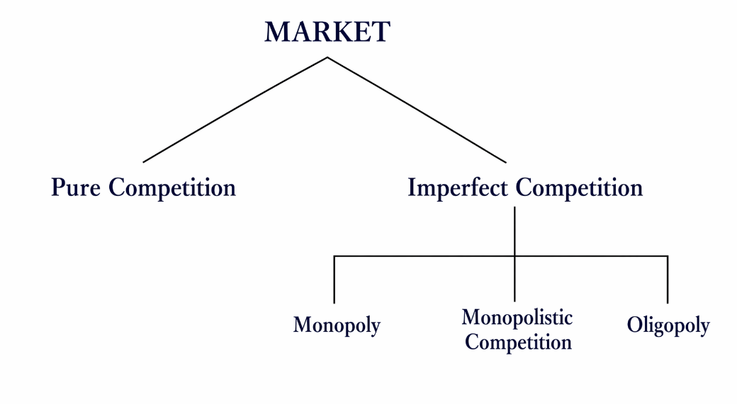

Market Type | Sellers | Price Control | Bangladesh Example
Pure Competition | Many (infinite) | None — price taker | Rice market, vegetable bazaar
Monopolistic Competition | Many | Some (small) | Restaurants in Dhaka
Oligopoly | Few (2–5) | Significant | Grameenphone, Robi, Banglalink
Monopoly | One | Full (price maker) | DESA electricity, Dhaka

SECTION C: Supply Equation — Mathematical Form
Your existing notes explain the demand equation (Qd = a - bP) but NOT the supply equation. From your class images:

Supply Function:
Qs = f(P) Quantity Supplied is a function of Price
Qs = c + dP Linear supply equation

Where:
c = quantity supplied when price is 0 (can be negative — seller needs min price)
d = how much Qs rises per 1-unit rise in P (positive — upward slope)
The PLUS sign confirms the DIRECT (upward) relationship

Both together:
Qd = a - bP (Demand — negative slope — downward)
Qs = c + dP (Supply — positive slope — upward)

SECTION D: Finding Equilibrium Algebraically
Your existing notes explain equilibrium using graphs and words. From Images 6 & 7, the class showed the full algebraic method:

D.1 General Formula
At Equilibrium: Qd = Qs
Given:
Qd = a - bP and Qs = c + dP

Step 1: Set them equal
a - bP = c + dP

Step 2: Rearrange (bring P terms together)
a - c = bP + dP
a - c = P(b + d)

Step 3: Solve for Equilibrium Price (P*)
P* = (a - c) / (b + d)

Step 4: Find Equilibrium Quantity (Q*)
Q* = a - b × P* (substitute P* into demand equation)
Q* = (ad + bc) / (b + d) [simplified form]

D.2 Worked Example
Given: Qd = 20 - 3P and Qs = 10 + 2P (from your class image)

Step 1: Set Qd = Qs
20 - 3P = 10 + 2P

Step 2: Rearrange
20 - 10 = 2P + 3P
10 = 5P

Step 3: Solve for P*
P* = 10 / 5 = 2

Step 4: Find Q* using demand equation
Q* = 20 - 3(2)
Q* = 20 - 6 = 14

ANSWER:
Equilibrium Price P* = 2
Equilibrium Quantity Q* = 14

Price (P) | Qd = 20 - 3P | Qs = 10 + 2P | Situation
1 | 17 | 12 | Qd > Qs → Shortage
2 | 14 | 14 | Qd = Qs → EQUILIBRIUM
3 | 11 | 16 | Qs > Qd → Surplus

D.3 Graph: Equilibrium Point
Supply curve (S) and Demand curve (D) cross at equilibrium point E:
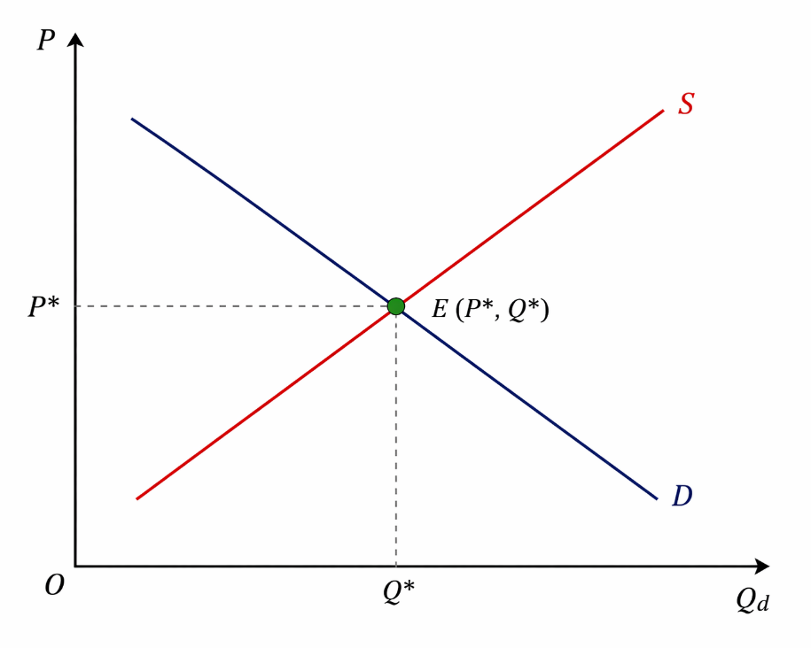
At E: Qd = Qs = Q*. Price is P*. Market is balanced — no pressure to change.

D.4 Graph: Surplus and Shortage Positions
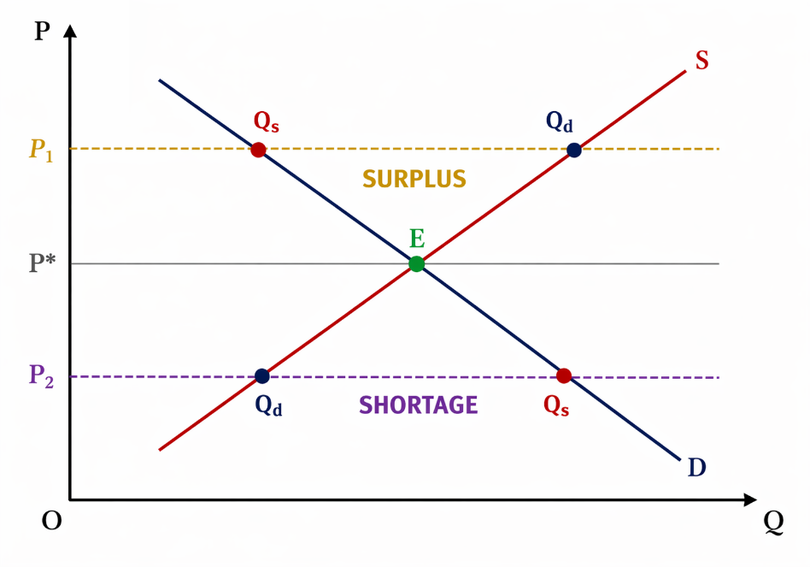
Price Level | Situation | Who has problem? | Market Response
Above P* (P1) | SURPLUS — Qs > Qd | Sellers cannot sell all goods | Sellers cut price → returns to P*
At P* | EQUILIBRIUM — Qd = Qs | No one — market is balanced | Price stays stable
Below P* (P2) | SHORTAGE — Qd > Qs | Buyers cannot get enough | Sellers raise price → returns to P*

D.5 Consumer Surplus & Producer Surplus
Consumer Surplus: The benefit buyers receive.
Area = ABOVE the price line P* and BELOW the demand curve D.
Triangle on top side of P* line.

Producer Surplus: The benefit sellers receive.
Area = BELOW the price line P* and ABOVE the supply curve S.
Triangle below P* line.

Total Surplus = Consumer Surplus + Producer Surplus
Measures the total benefit to society from trade.

SECTION E: Demand Curve — Slope Calculation
From Image 4 — your class worked this with actual points. This method is NOT in your original notes.

E.1 Points on the Demand Curve
Given equation: Qd = 20 - 3P
Price (P) | Calculation | Quantity Demanded (Qd) | Point on graph
P = 3 | 20 - 3(3) = 11 | 11 units | (P=3, Qd=11)
P = 2 | 20 - 3(2) = 14 | 14 units | (P=2, Qd=14)
P = 1 | 20 - 3(1) = 17 | 17 units | (P=1, Qd=17)

E.2 Graph: Demand Curve with Three Points
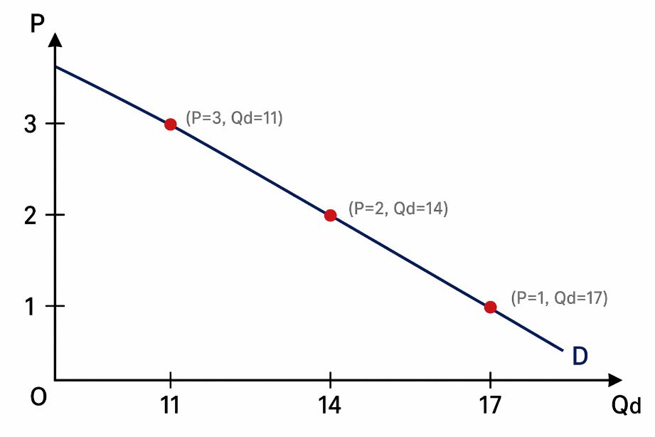

E.3 Slope Calculation
Slope of Demand Curve
Slope of Demand Curve = Change in P / Change in Qd = ΔP / ΔQd

Using points (P = 2, Qd = 14) and (P = 3, Qd = 11):
ΔP = 2 − 3 = -1
ΔQd = 14 − 11 = 3

Slope = -1 / 3 = -1/3

Meaning:
For every 3-unit INCREASE in Qd, price FALLS by 1 unit.
The slope is NEGATIVE → confirms the demand curve slopes DOWNWARD.

SECTION F: Movement vs. Shift — With Diagrams
Images 4 & 5 show two separate diagrams for this. Your notes explain it but without these specific diagrams.

F.1 Movement ALONG the Demand Curve
Caused by: PRICE of the same good changes. The curve stays in place — only the point moves.
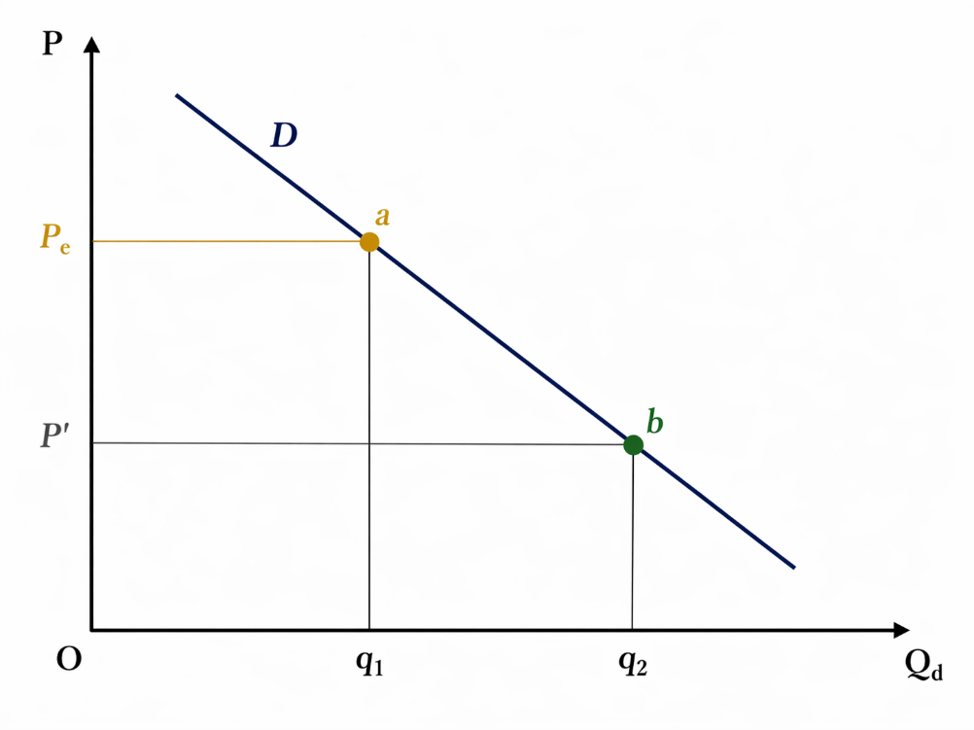
Point moves from "a" to "b" on the SAME curve. Quantity changes from q1 to q2. This is called: Change in Quantity Demanded.

F.2 Shift OF the Demand Curve
Caused by: Non-price factors (income, tastes, related goods, expectations, # buyers). The ENTIRE curve moves.
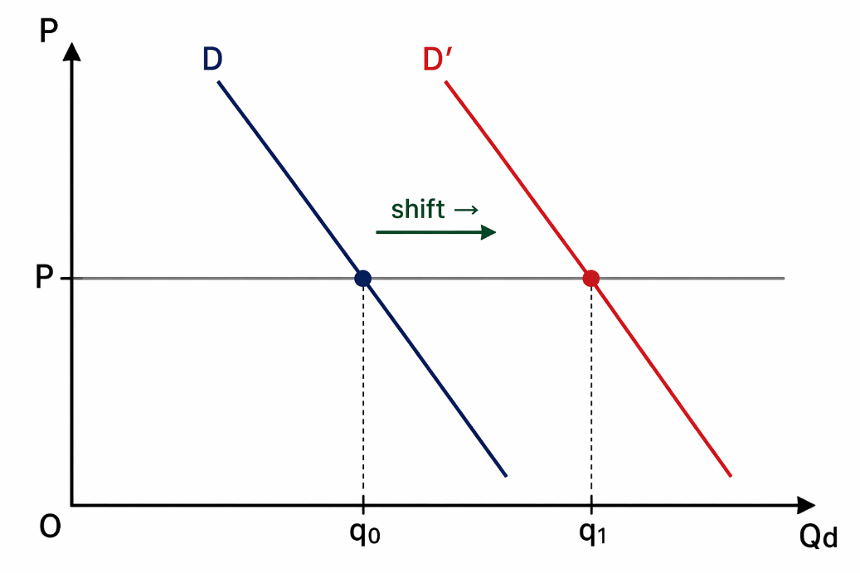
The whole curve moves from D to D'. At the SAME price P, quantity demanded increases from q0 to q1. This is called: Change in Demand.

 | Movement Along Curve | Shift of Curve
Cause | Price of the SAME good changes | Income, tastes, related goods, expectations, # buyers
What moves? | One point slides on same curve | Entire curve moves to new position
Technical name | Change in Quantity Demanded | Change in Demand
Graph effect | Move up or down same line | A new curve appears left or right

SECTION G: Price Elasticity of Demand (PED)
Images 9 & 10 cover elasticity. This topic is completely missing from your existing notes.

G.1 What Is Elasticity?
Price Elasticity of Demand (Ep or Ed) measures how SENSITIVE quantity demanded
is to a change in price.

Question: If price rises by 10%, by how much does Qd fall?
The answer is the elasticity value.

G.2 Formula
Price Elasticity of Demand (Ep):
Ep = % Change in Qd / % Change in P

Expanded form:
Ep = (Change in Qd / Initial Qd) ÷ (Change in P / Initial P)

Point elasticity (math/calculus form):
Ep = (dQ / dP) × (P / Q)

Note:
Ep is always NEGATIVE for demand (inverse relationship).
We report |Ep| (absolute value) to compare magnitudes.

G.3 Worked Example 1 (from Image 9)
Given: When P = 10, Q = 200. When P = 8, Q = 250.
Step 1: Find changes
dP = 10 - 8 = 2
dQ = 200 - 250 = -50

Step 2: Apply formula
Ep = (dQ / dP) × (P / Q)
Ep = (-50 / 2) × (10 / 200)
Ep = -25 × 0.05
Ep = -1.25

Interpretation:
|Ep| = 1.25 > 1 → Demand is ELASTIC
A 1% rise in price leads to a 1.25% fall in quantity demanded.

G.4 Worked Example 2 (from Image 10)
Given: P = 10, Q = 200, then P = 9, Q = 300.
Case 1:
dP = 1, dQ = 100
Ep = (100 / 1) × (10 / 200)
Ep = 100 × 0.05 = 5
|Ep| = 5 > 1 → Highly ELASTIC

Case 2 (Image 10 bottom):
P changes from 10 to 5, Q from 160 to 210
dP = 5, dQ = 50
Ep = (50 / 5) × (5 / 210)
Ep = 10 × 0.024 = 0.024
|Ep| = 0.024 < 1 → INELASTIC

G.5 Elasticity Classification Table
Value of |Ep| | Type | Meaning | Graph Shape
|Ep| > 1 | ELASTIC | Qd changes MORE than price change | Flat (gentle) curve
|Ep| = 1 | Unit Elastic | Qd changes by same % as price | Moderate slope
|Ep| < 1 | INELASTIC | Qd changes LESS than price change | Steep curve
|Ep| = 0 | Perfectly Inelastic | Qd does not change at all | Vertical line
|Ep| = ∞ | Perfectly Elastic | Any price rise → Qd drops to 0 | Horizontal line

G.6 Graph: Elastic vs. Inelastic Demand
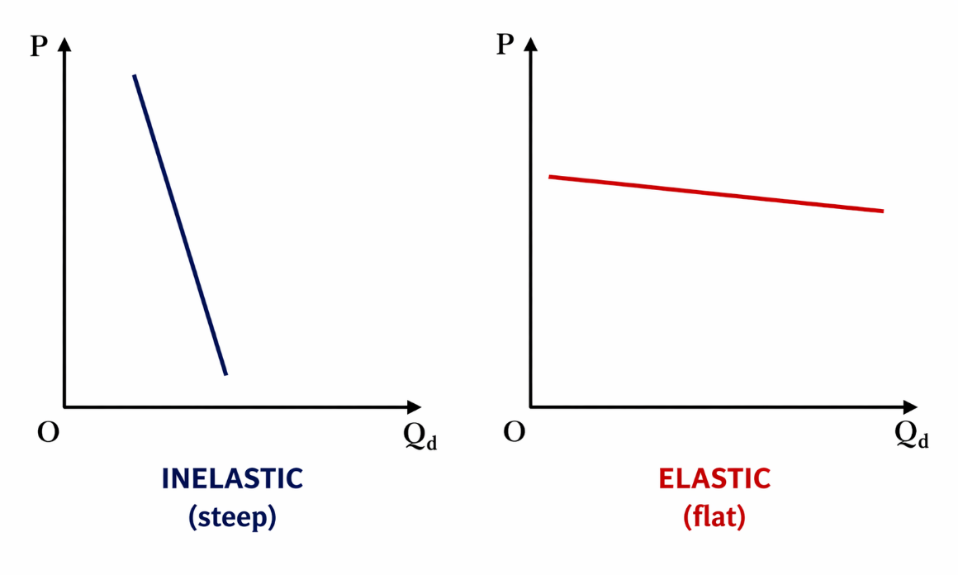
Left (steep/inelastic): Small change in Qd for a big change in P.
Right (flat/elastic): Large change in Qd for a small change in P.

SECTION H: Simultaneous Shift Scenarios
Image 8 shows specific scenarios not detailed in your existing notes:

Scenario | Demand Shift | Supply Shift | Price Result | Quantity Result
Consumer income ↑ + Input cost ↓ | RIGHT (increase) | RIGHT (increase) | AMBIGUOUS | RISES for sure
Consumer income ↓ + Input cost ↓ | LEFT (decrease) | RIGHT (increase) | FALLS for sure | AMBIGUOUS
Consumer income ↑ + Input cost ↑ | RIGHT (increase) | LEFT (decrease) | RISES for sure | AMBIGUOUS
Consumer income ↓ + Input cost ↑ | LEFT (decrease) | LEFT (decrease) | AMBIGUOUS | FALLS for sure

SECTION I: PPF — Production Possibility Frontier
Image 1 shows a PPF diagram. This is an economics model not in your Chapter 4 notes.

PPF = Production Possibility Frontier
Also called: PPC (Production Possibility Curve)

Definition: A curve showing ALL the maximum combinations of two goods that an
economy can produce with its available resources and technology.

I.1 Graph: PPF Curve
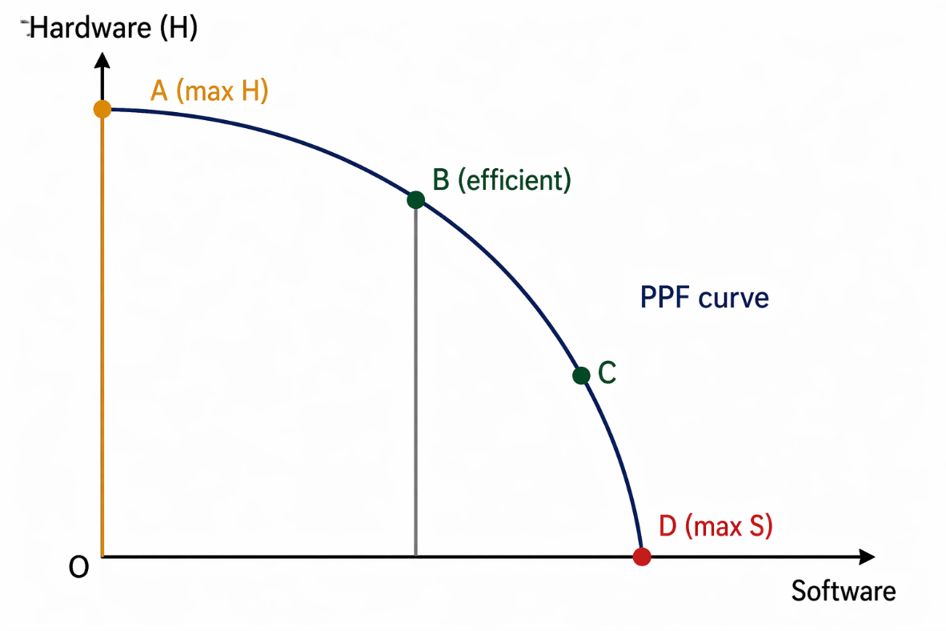

Position | Meaning | Efficiency
ON the curve | Maximum output — using all resources | Efficient (best use of resources)
INSIDE the curve | Output below maximum — wasting resources | Inefficient
OUTSIDE the curve | Currently impossible — beyond capacity | Unattainable

I.2 Key Points about PPF
- The PPF is CONCAVE (bowed outward) due to increasing opportunity cost.
- To get more of one good, you must give up some of the other — this is opportunity cost.
- Economic growth SHIFTS the PPF outward (better technology or more resources).
- The PPF shows SCARCITY and CHOICE visually — you cannot have unlimited of both goods.

SECTION J: Economic Models & Circular Flow
Image 2 shows Economic Models branching into PPF and Circular Flow of GDP.

Economic Model: A simplified picture of reality used to understand how the economy works.

Two main models in Principles of Economics:
1. PPF (Production Possibility Frontier) — shows resource allocation and trade-offs
2. Circular Flow of GDP — shows money and goods flowing between households and firms

J.1 Circular Flow of GDP
GDP = Y = C + I (simplified: no government, no foreign trade)

C = Consumption expenditure (households buy goods/services from firms)
I = Investment (firms buy capital goods)
S = Savings

Key equilibrium:
I = S (Investment equals Savings in a simple closed economy)

Flow:
Households earn income (wages, rent) from firms via factor markets.
Households spend that income buying goods from firms via goods markets.
This circular flow keeps repeating — that is GDP.

QUICK REFERENCE — All New Formulas Added
Demand Equation:
Qd = a - bP
Supply Equation:
Qs = c + dP

Equilibrium Price:
P* = (a - c) / (b + d)
Equilibrium Quantity:
Q* = (ad + bc) / (b + d)

Demand Slope:
ΔP / ΔQd (always negative)
Supply Slope:
ΔP / ΔQs (always positive)

Price Elasticity:
Ep = (dQ/dP) × (P/Q)

Elastic Demand:
|Ep| > 1
Inelastic Demand:
|Ep| < 1

GDP (simple):
Y = C + I

Savings = Investment:
I = S

End of Complete Master Study Guide — Chapter 4: The Market Forces of Supply and Demand
Principles of Economics, 8th Edition | N. Gregory Mankiw

